**Issue 4**: The placements of the input fields “FIRST NAME, MI and LAST NAME” are confusing for the user

**Description**: First name, MI and Last name are asked in the form. But it is confusing for the user, if he/she needs to provide the card’s First name, MI, Last name or the Billing addressee First name, MI, Last name.

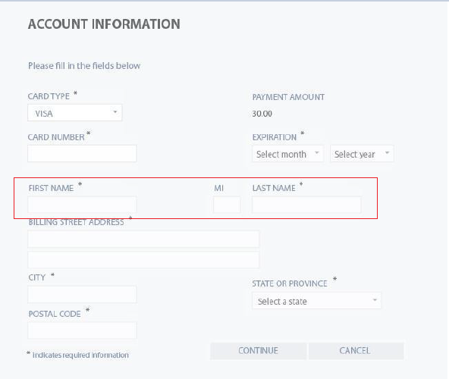

**Expected Behavior**: The form should be clear in the placement of FIRST NAME, MI, LAST NAME. A title separation of the card details and address details should solve the issue.

**Severity**: Critical